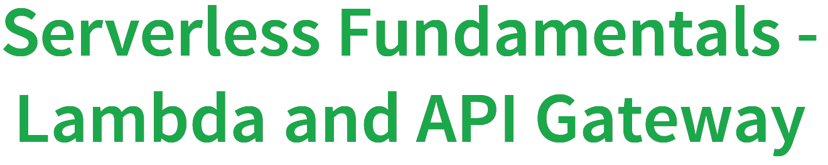

**Section 6 - Getting started with Serverless – AWS Lambda:**

**61. Step 00 - Serverless Overview:**

* Most of the application now adopting this server less approach for developing their application
* We will learn three very important component for developing serverless application
* **(1)-** AWS Lambda (**2)-** AWS API Gateway (**3)-** Amazon Cognito

**62. Step 01 - Introduction to Serverless**

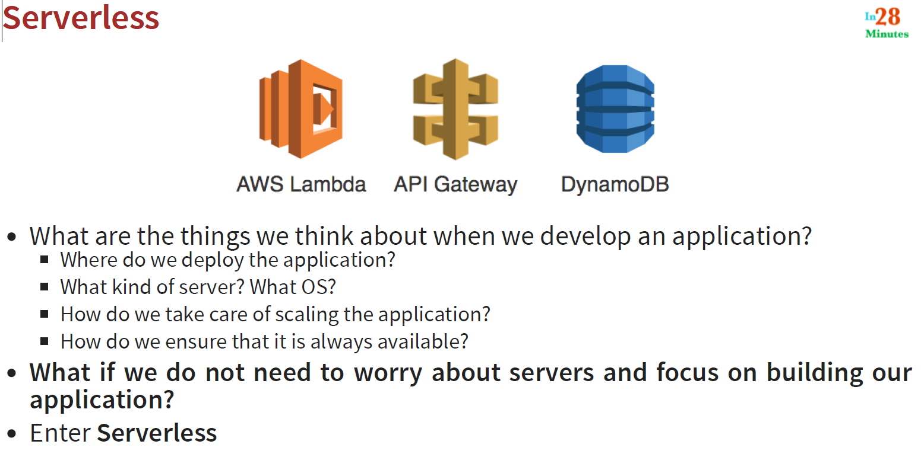

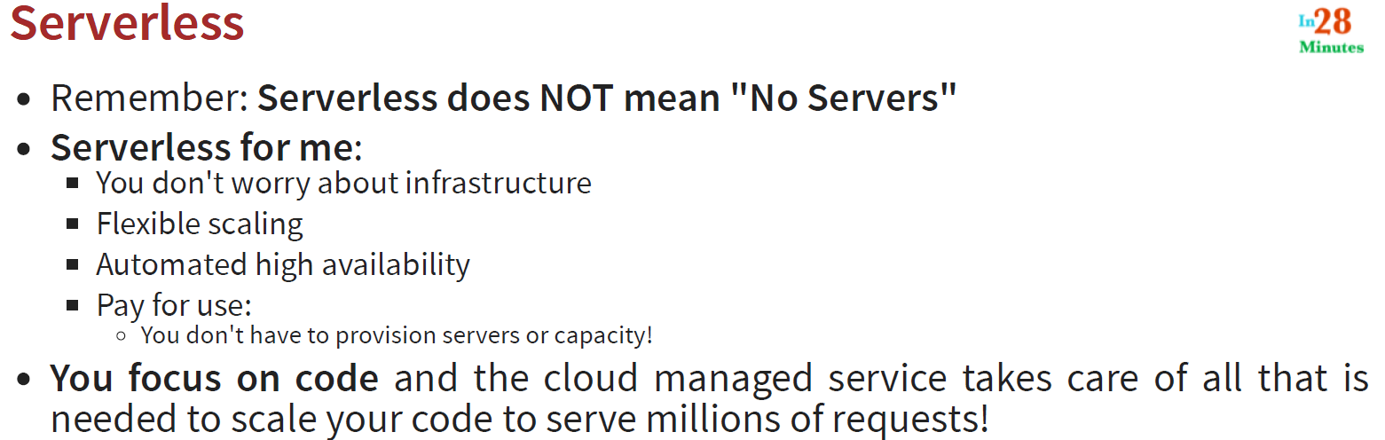

**Note**: Pay for use means you have to pay as per your requirement and use of the server. In the peak time like festive season when your application should be highly available then you can increase the capacity and pay accordingly. Basically ASW lambda means pay as you use. I.e. Serverless means AWS Lambda that’s how popular lambda is.

**63. Step 02 - Getting started with AWS Lambda**

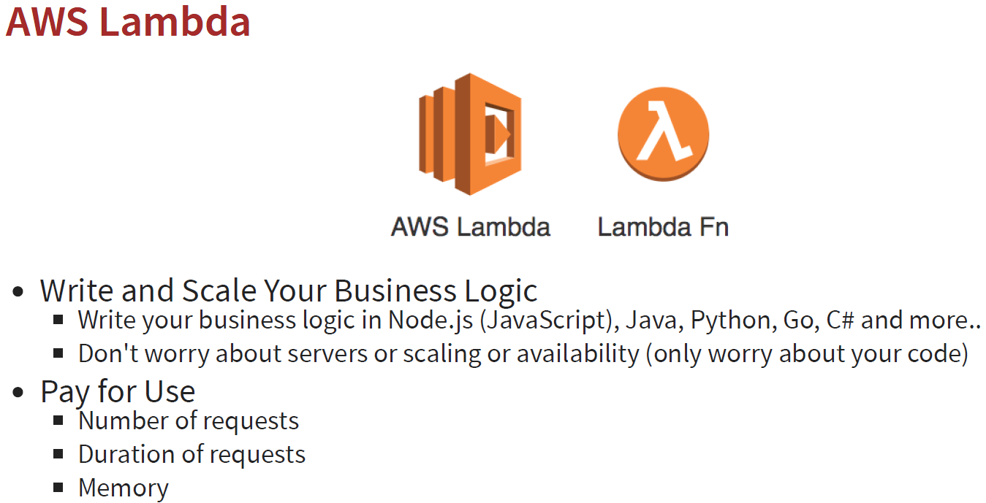

So if you number of request gets increased or request takes time to process then you have to pay accordingly and how much your lambda function is taking memory for processing the requests.

**64. Step 03 - Creating Your First Serverless Function with AWS Lambda**

1- Go to AWS Management Console.

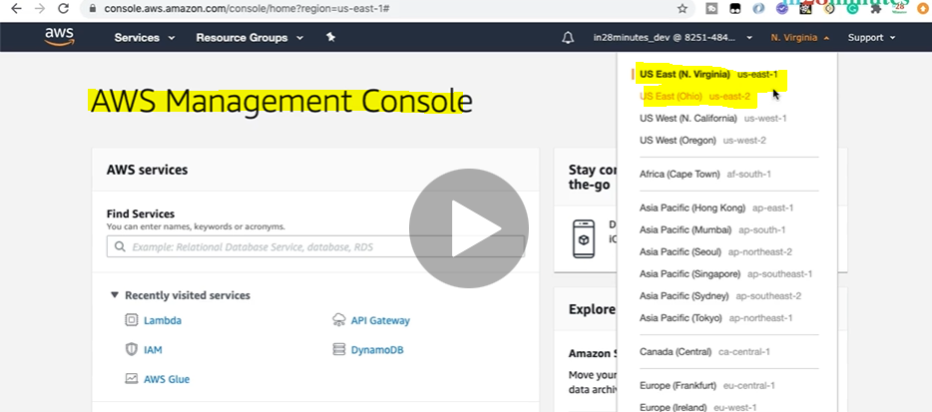

2- Now Launch the AWS Lambda Service just by searching AWS Lambda in the search box.

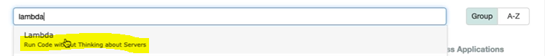

As here is mentioned Run code without thinking about servers.

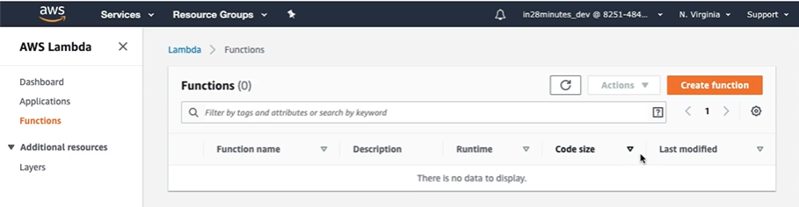

Now click on button “Create function” to create new Lambda function.

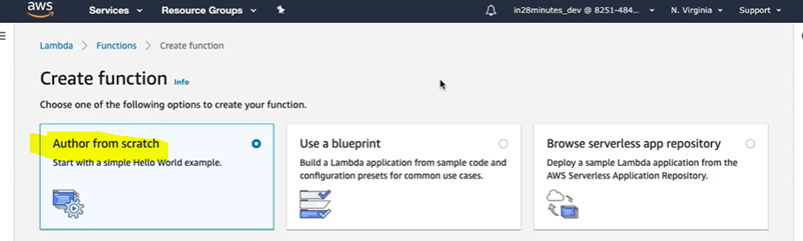

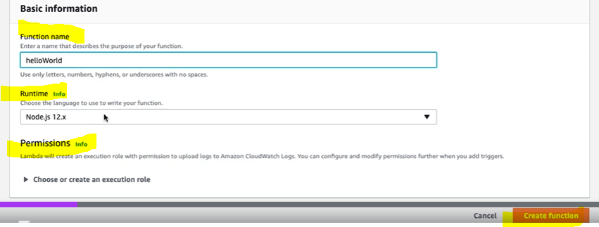

Here we get several options to create Lambda function like From Scratch or use a blueprint or browse app repo. Here we will choose from scratch.

Here we can give the function name, can select the Runtime (Here we get wide verity of runtime like java, .Net, Node.Js etc)

The next thing that we will configure is permission. This Lambda function might need to talk to third party application like database then in that case it permission to talk to database. So we can provide the permission just by creating roles. By default Lambda service create role for us so that we don’t need to worry about it.

Finally create function by clicking on button. It would take little time approx 30 sec. and once function get created we will get the successful message like:

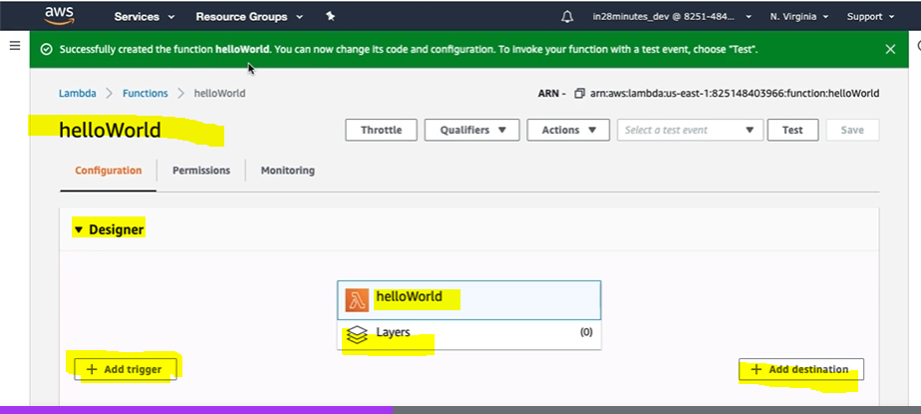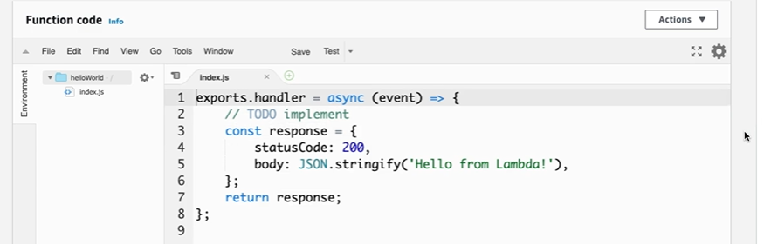

And on this page we can configure code and configuration for our lambda expression. Here we can include some design using Designer and can add trigger to trigger our lambda function. We can add some code and add destination which tells what should happen when lambda function get triggered. We can see the editor where we can write the function code and if we go further down then we will see the configuration related to Lambda function.

Now let’s test the lambda function: So to test lambda function first we will have to create the test event on clicking on the **“Test”** button.

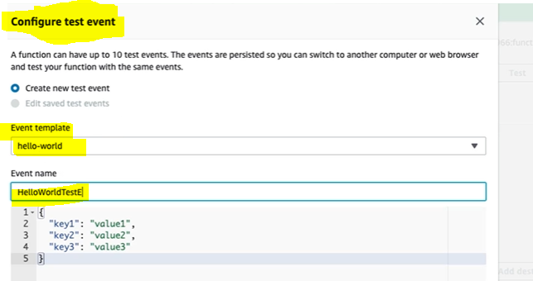

Here we can create the Test event based on the template. Here we can see some predefined JSON contains Key-Values and we want to send this as an input to our Lambda function.

So Event is nothing but JSON which we are sending as an input into the Lambda function.

Click on create to create lambda function event and now the created event will start showing in the event box.

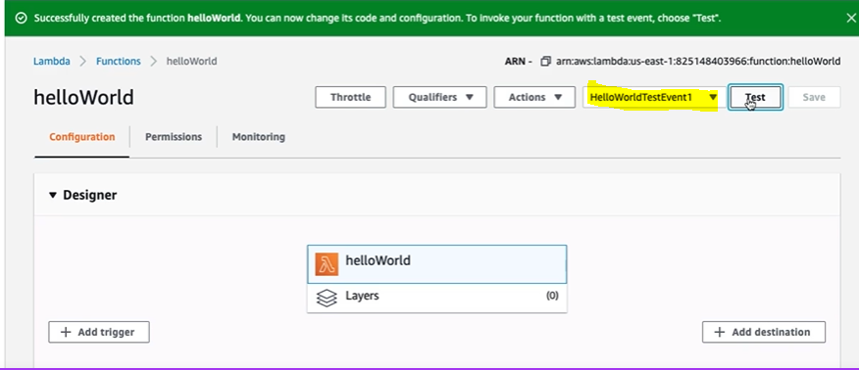

Now let’s click on Test to test event:

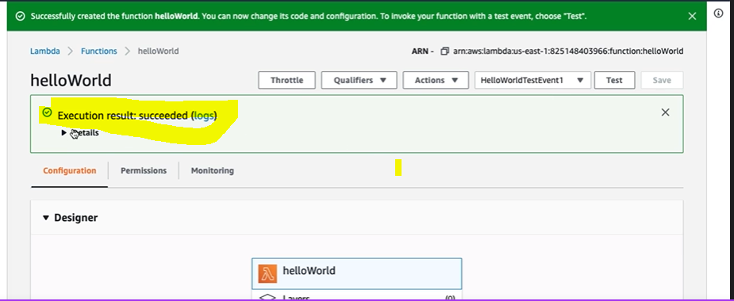

And we can see the Execution Result : Succeeded:

To show the detail let’s click on the details:

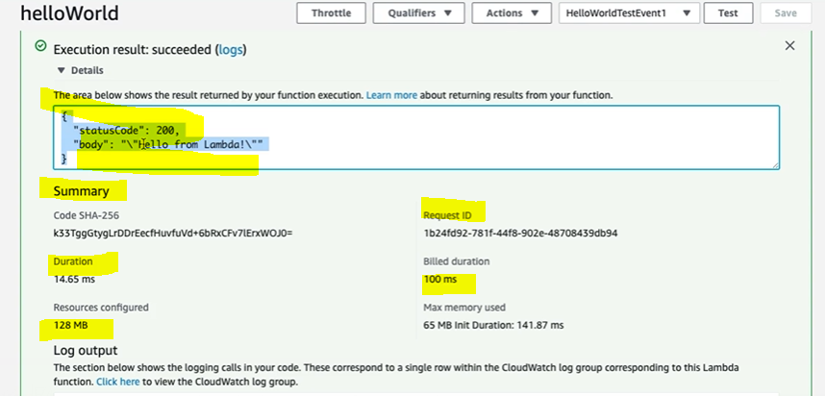

Here we can see the http status and in the summary we can see lot of the information.

**65. Step 04 - Understanding Your First Serverless Function - AWS Lambda Event and Re**

In the last step we just created lambda function and test with its default JSON request. Now let’s create some more code using editor and try to execute.

1. We will put one console.log to see the request coming from the lambda expression
2. We will try to get the value based on the key defined in the request
3. We will create some variable using let keyword and try to print their value in the JSON format
4. We will create header of the content type

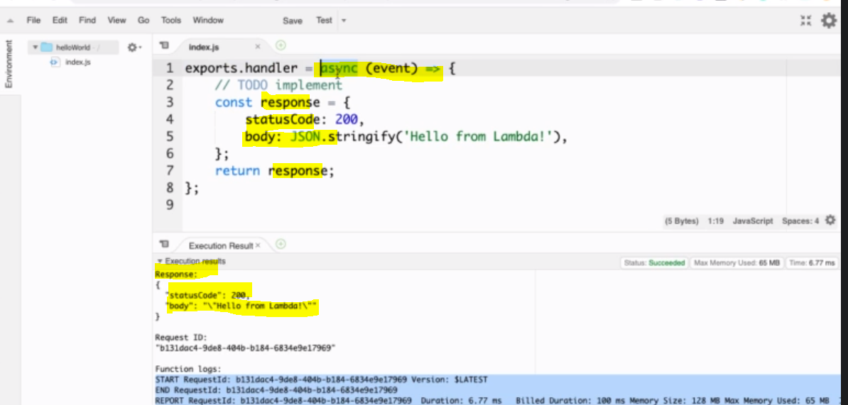

Here we have just showing the response: **statusCode** and **body** and same we can see in the Response

**------------------------------------------------------------------------------------------------------------------------------------------------**

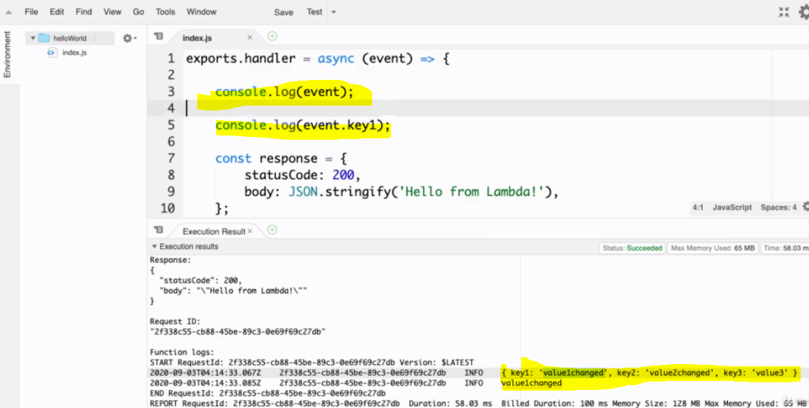

We have kept one console.log for printing the event which is being sent from the Lambda function (key-value) json. Save and Test Now.

**------------------------------------------------------------------------------------------------------------------------------------------------**

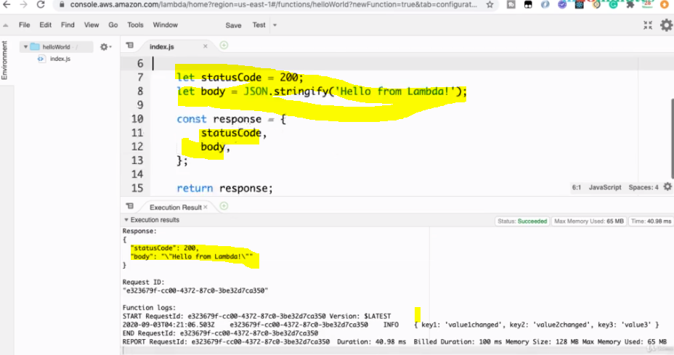

**Return the response using let key word and its value:**

**Now let’s create our own todo and return same in the response:**

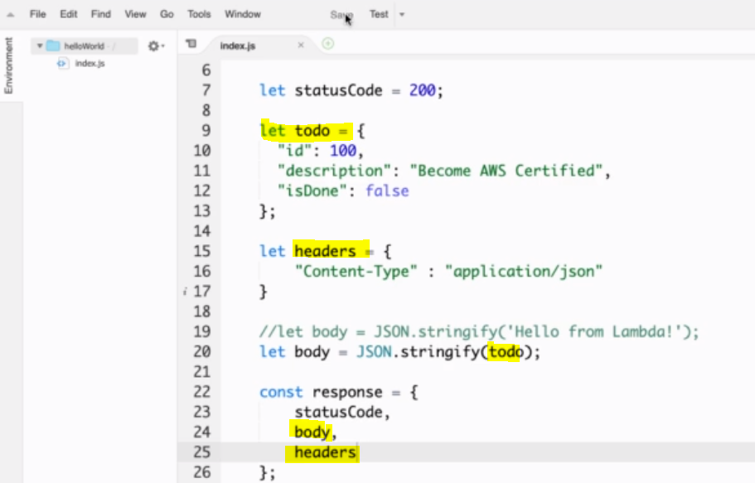

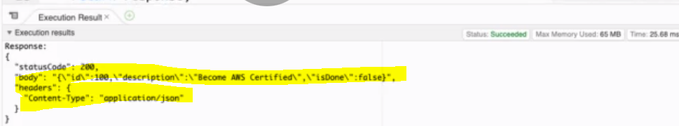

**Here in the response we can see our own todo list in the response**

**So in this way we can create lambda function and test and get the response. Here we have configured JSON request in the event and same we are receiving here in the event.**

**66. Step 05 - Playing with Your First Serverless Function - AWS Lambda Context**

**So far we have seen one input event in the Lambda function which tells about the incoming request detail. The other parameter that we can add is along with the event is called [context]. This context represent the execution context of the lambda function. So this lambda function is going to execution in a specific environment and we want to get that detail of context, that’s where context variable will help us.**

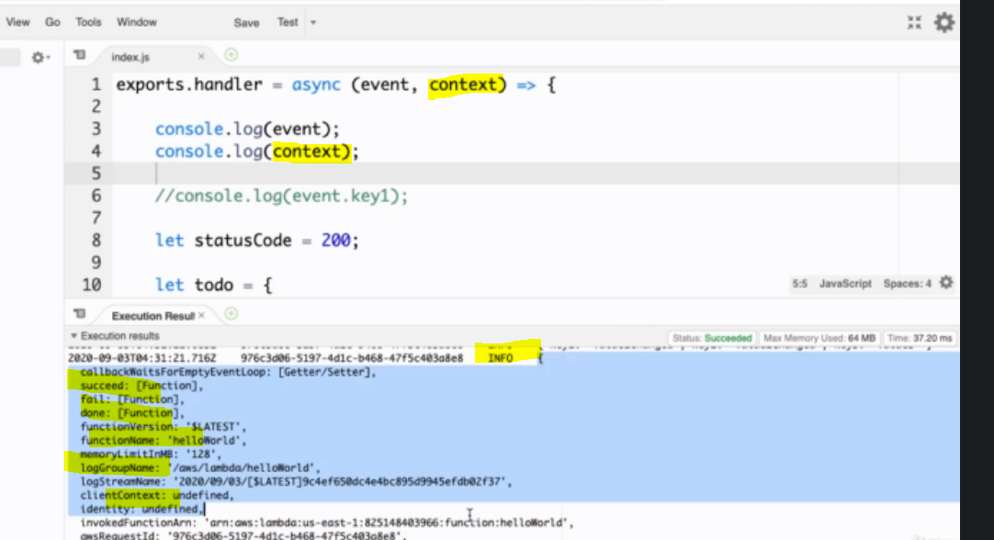

**Let’s see in other tab:**

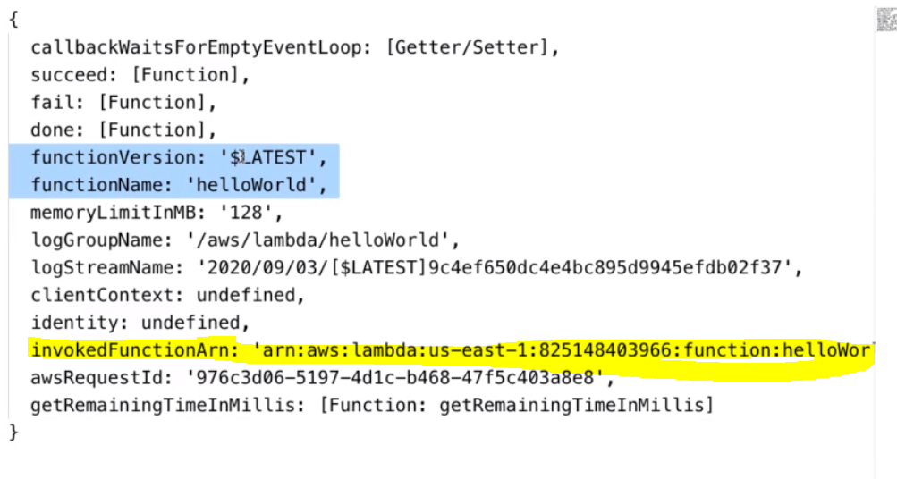

**So we can see lot of information about the lambda function context info like function Version, its name etc. Amazon Resource Name (Arn).**

**The default max execution time for lambda function is 3 sec:**

**Now let’s try to print this context from the lambda function i.e. from the code using context variable.**

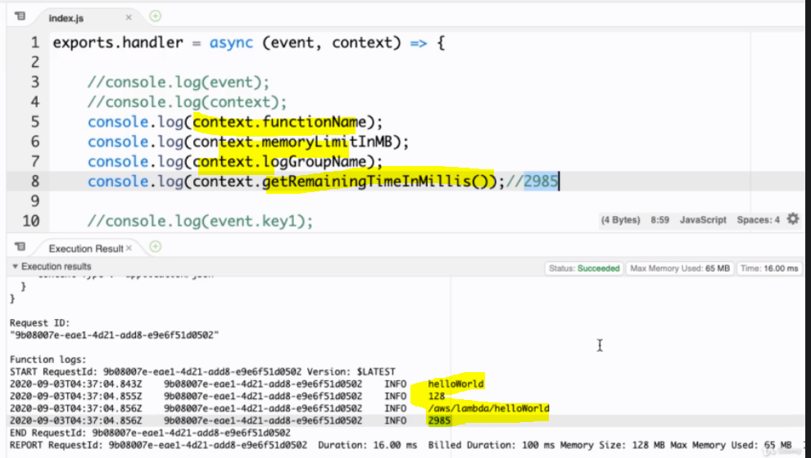

**Since the max execution time for lambda function is 3 ms. so here using getRemainingTimeInMiliIs () function we can get the remaining time to execute the remaining code of the lambda function. So here we have got 2985 milisecond to execute the remaining code after executing line number 8.**

**So in this step we have explored context: and we have seen how to get the execution context:**

**67. Step 06 - Playing with Your First Serverless Function - AWS Lambda Basic Setting**

In this step we will see some basic setting that we can configure around our lambda function.

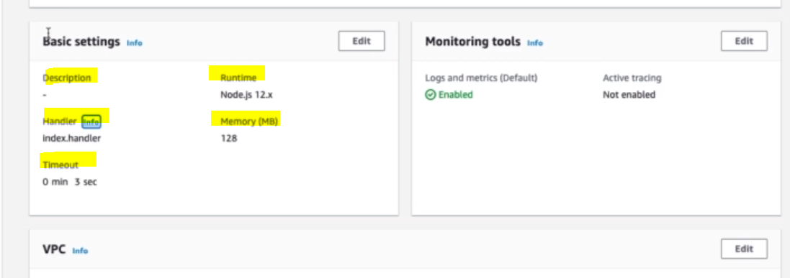

So we can configure the Description, Runtime (Here in this case it’s Node.js). We can configure the Handler (which is nothing but the module or component (which is in this case index.js and we have used in the code using export.handler.

We can set the memory taking in the execution and we can set up 3 GB memory

<https://aws.amazon.com/lambda/pricing/>

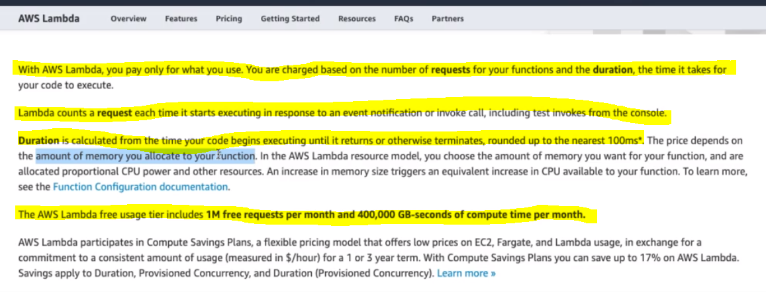

So since lambda function cost depends on Memory and execution time both so we need to configure both the value accordingly to get best result and to reduce the cost and best execution time.

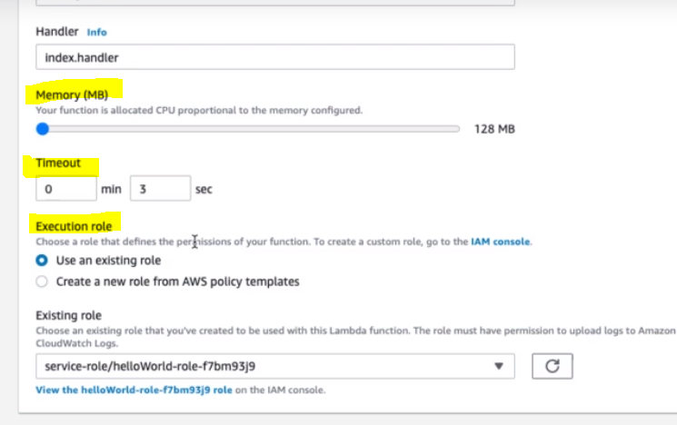

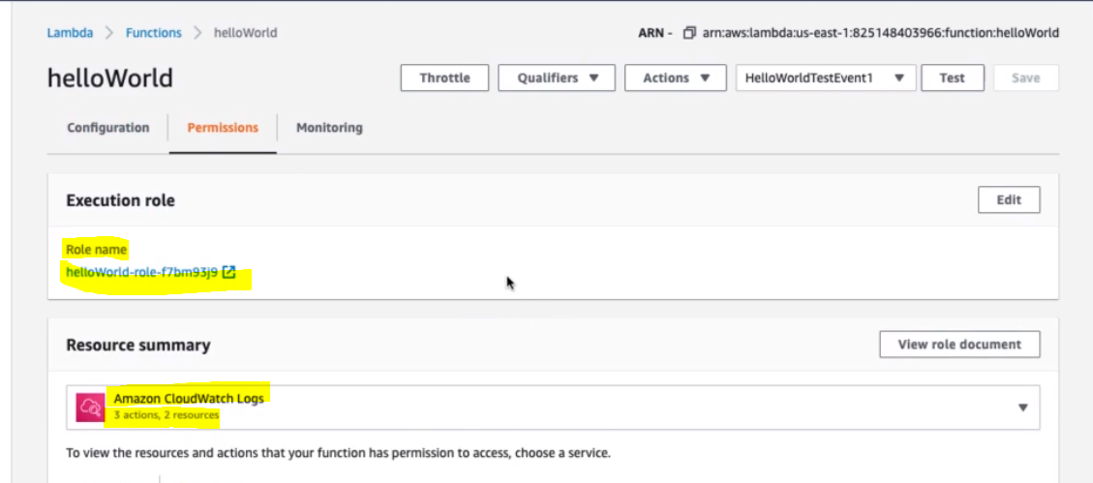

**68. Step 07 - Monitoring your AWS Lambda Serverless Functions - CloudWatch and XRay**

When we are using Lambda service then we are only responsible for writing the code for the lambda function, the lambda service is responsible for auto scaling to meet the higher number of request.

We can monitor our Lambda function using cloud watch.

Using XRay we can enable tracing.

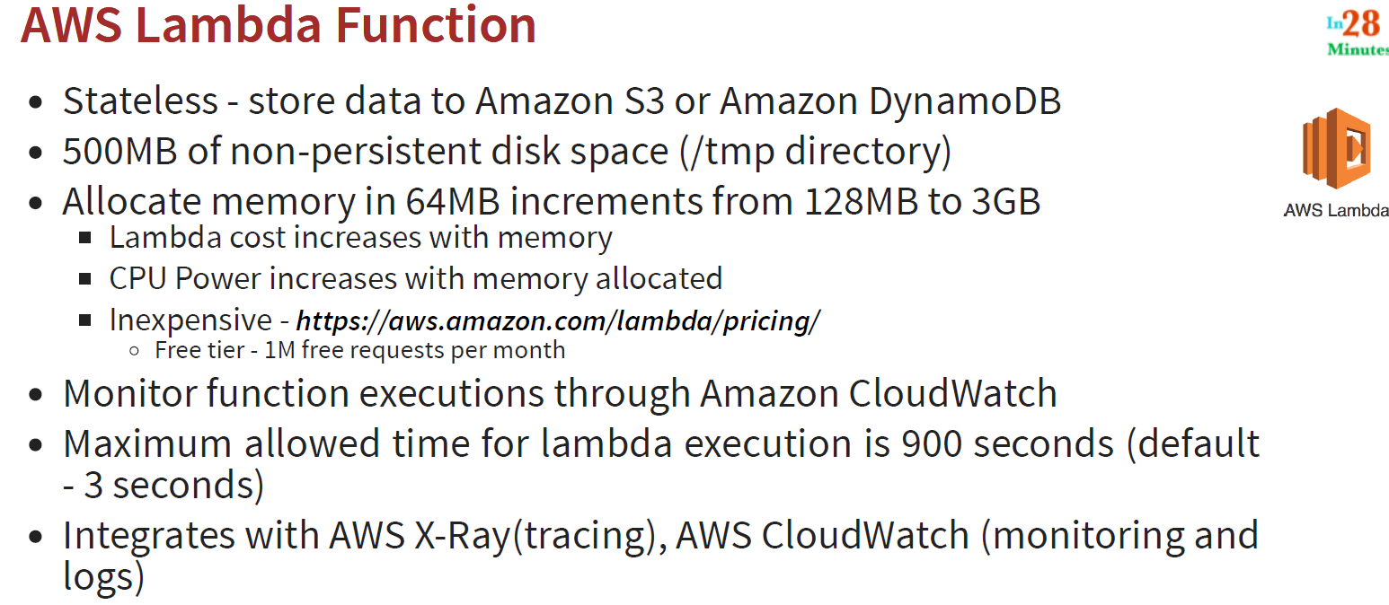

**69. Step 08 - Versioning your AWS Lambda Serverless Functions - Versions and Alias**

1. Versioning is very important feature when we talk about REST API. If we want to have multiple version of REST API
2. Behind this Rest API we will have Lambda function and therefore we would also be able to version of Lambda function
3. How can we create different version of lambda function? That we will look here.

Go to your own created Lambda function HelloWorld

Go to Action > Publish New Version

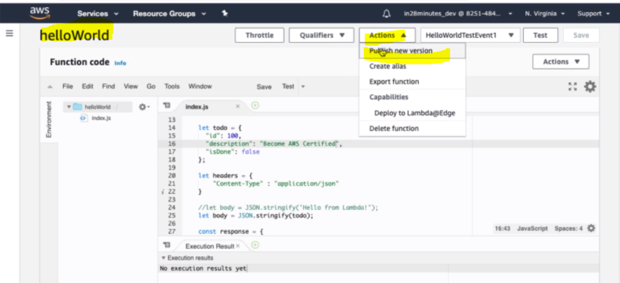

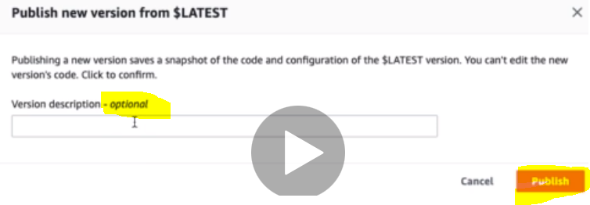

Since Version description is optional so just click on Button Publish to get new version of lambda function

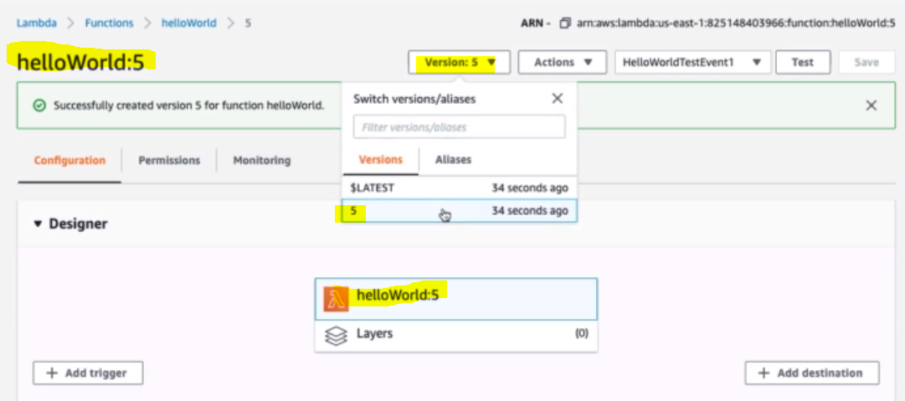

And now we can see that we have got new version of Lambda function helloWorld: 5 is created.

And once the new version gets created then we can Test this new version using test button.

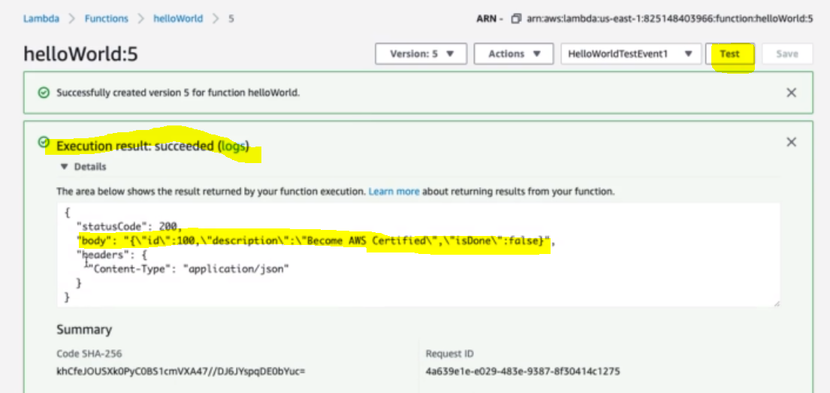

And we have got the same result. 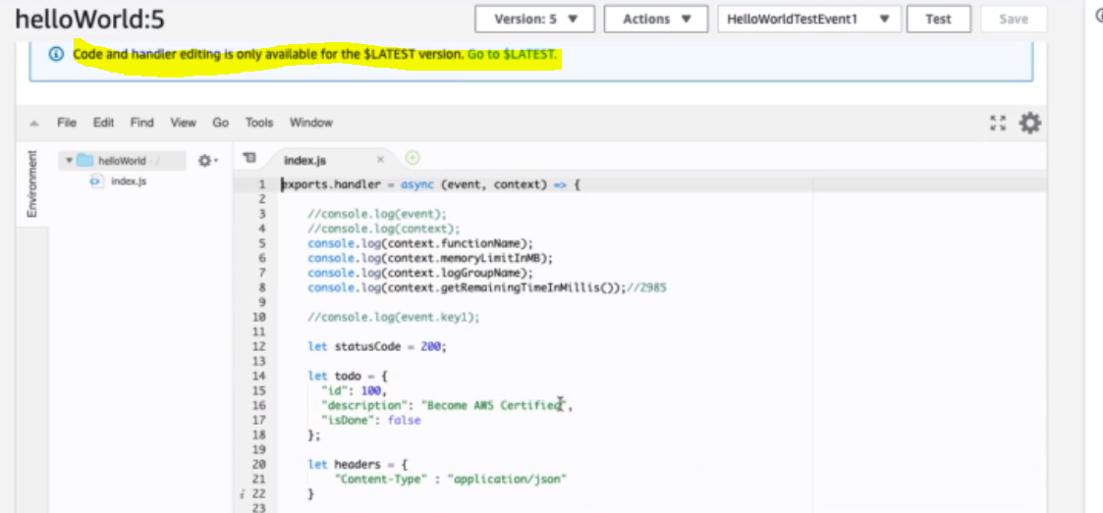

The interesting this that once we create the version then we would not be able to edit the code of this version.

To edit go to $LATEST version:

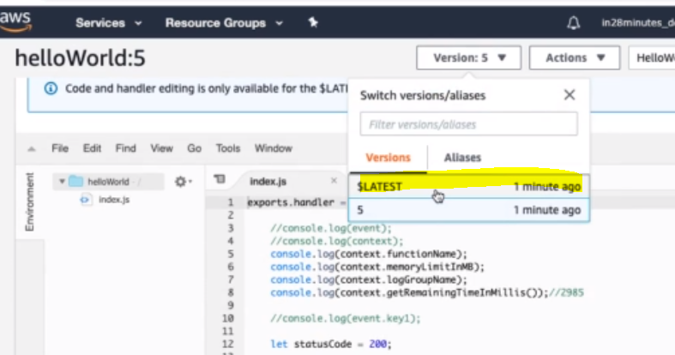

And here we can edit the code according to our need.

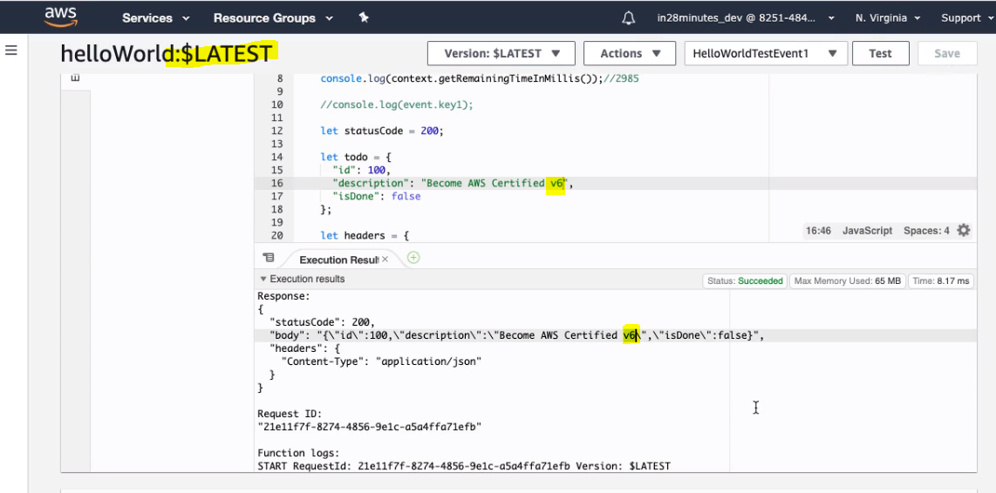

Save and Test:

Now we have we have got another version with new change. So now we can publish the new version again.

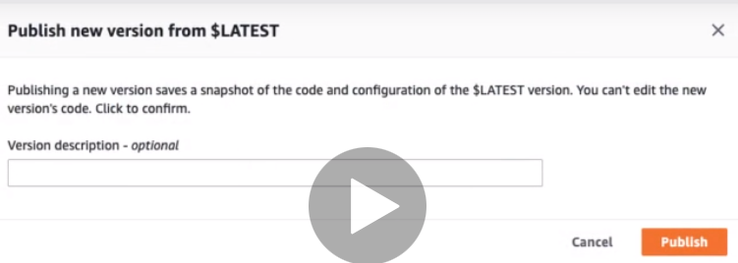

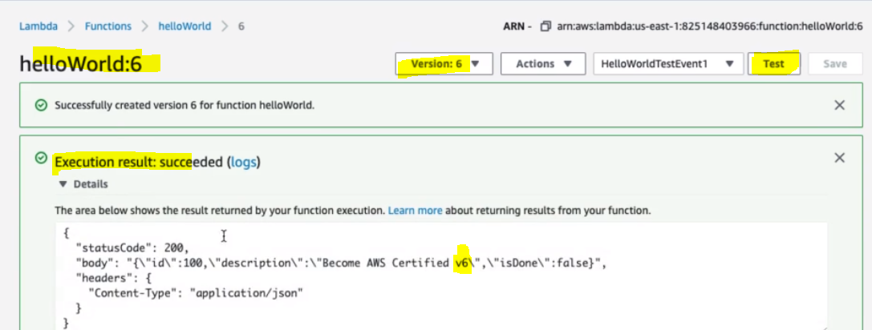

Now we have version 5 and 6 and we can run these versions independently according to our need.

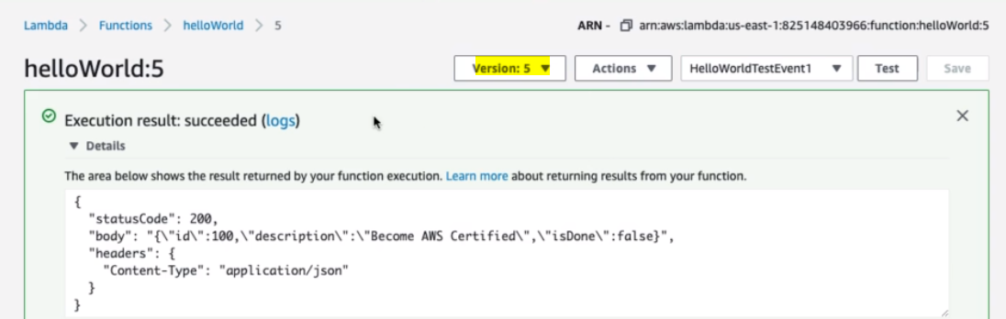

Version 5 tested:

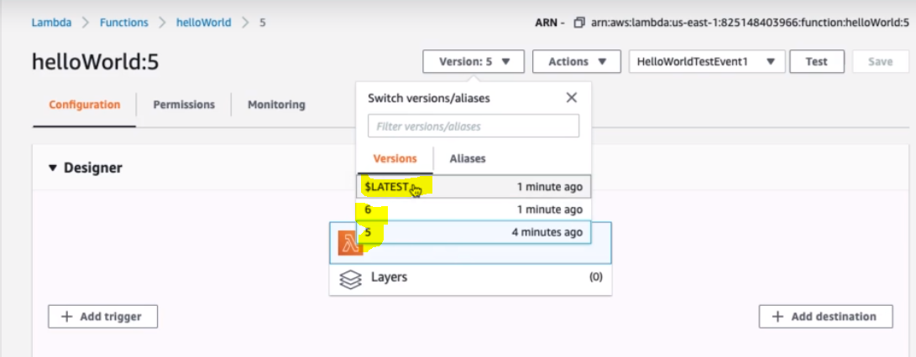

Note: So here we have got two versions 5 and 6 but we cannot edit them, we can edit only $LATEST version.

|  |  |  |
| --- | --- | --- |
|  |  |  |

So let’s say we have REST API of different version which is being created using lambda function then we can use this lambda function version in the development environment, QA environment, and Prod environment. So whenever we change the lambda function code then we used create a new version and same version we used to update in the API GATEWAY also to point the newest version. Instead of pointing version number we can create the Aliases against the version number for different kind of environments and can use the Aliases name instead of pointing version number.

**Section:7- Exploring Serverless with AWS lambda in Depth:**

**70. Step 01 - Understanding Concurrency of Lambda Functions**

**What is Reserved Concurrency and why do we need it?**

Before explaining Reserved Concurrency, first let’s talk about **Function Concurrency (FC):**

A FC is the number of lambda function instances serving request at a given time.

Q: Now the question comes how the AWS lambda does control the function concurrency? I.e. how we tell AWS lambda that we need this many lambda instances running in parallel?

So the first solution is by imposing Regional quota. This is the default quota applied by AWS and shared by all the function in a specific Region and the default regional quota is 1000 i.e. by default 1000 lambda function instances can be running in parallel in a specific region. For example if we create 20 lambda function in a specific region then 1000 max lambda function instances can be created of that 20 lambda function and which will run in parallel in a specific region.

Q: Now from these 1000 instances we want to ensure that a critical lambda function can always run then how to do it?

A: By using Reserved Concurrency. So out of the total 1000 regional quota, we want to reserve 300 instance for dev and 300 for prod and remaining for other instances (1000-300-300= 400 instances). So for a specific function we can reserve the specific number of instances which is nothing but Reserved Concurrency.

**So in short:**

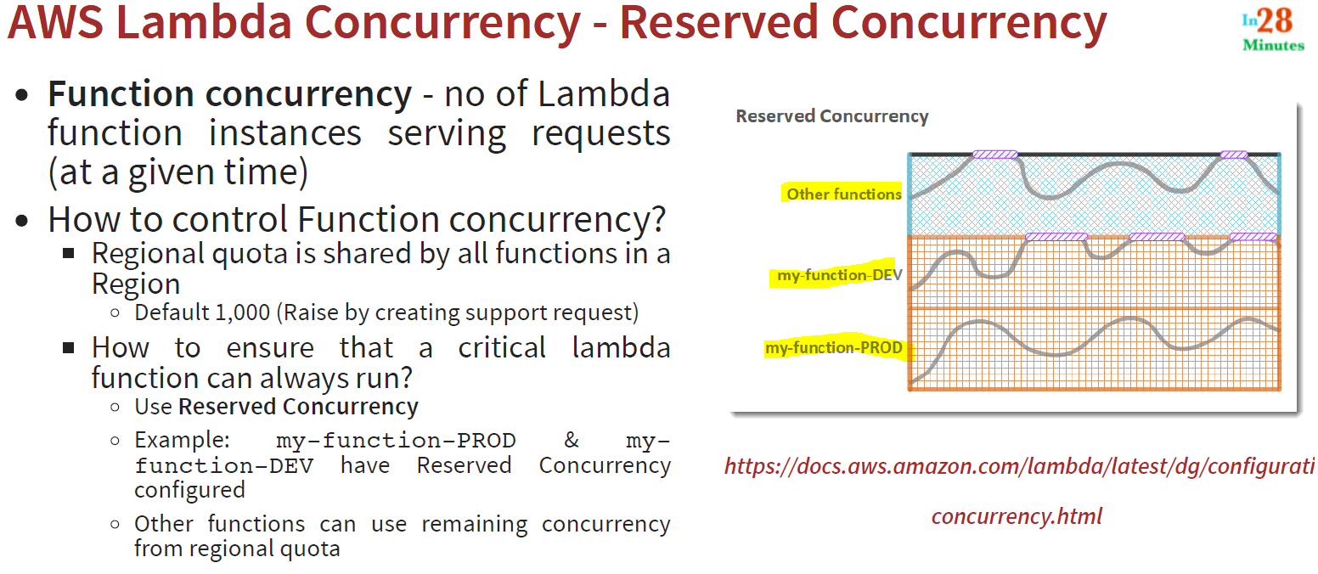

Now let’s see where we can configure this concurrency:

* Go to your helloWorld Lambda function, Scroll down and go to the Concurrency section of the same page

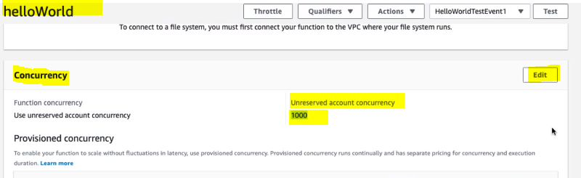

So initially we can see that here we have 1000 Unreserved account concurrency and we can reserve just by editing

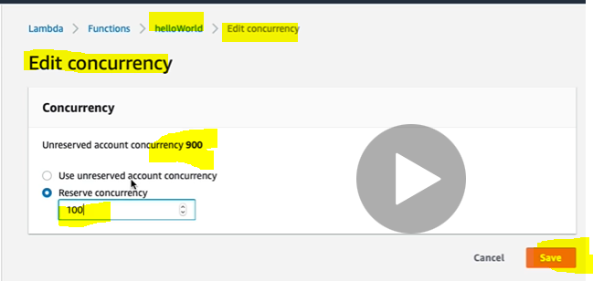

So as here we can see that we have reserved 100 concurrency for helloWorld lambda function and now we have 900 remaining unreserved account concurrency that can be used by other lambda function of the same region.

**71. Step 02 - 01 - Understanding AWS Lambda Execution Context**

In short:

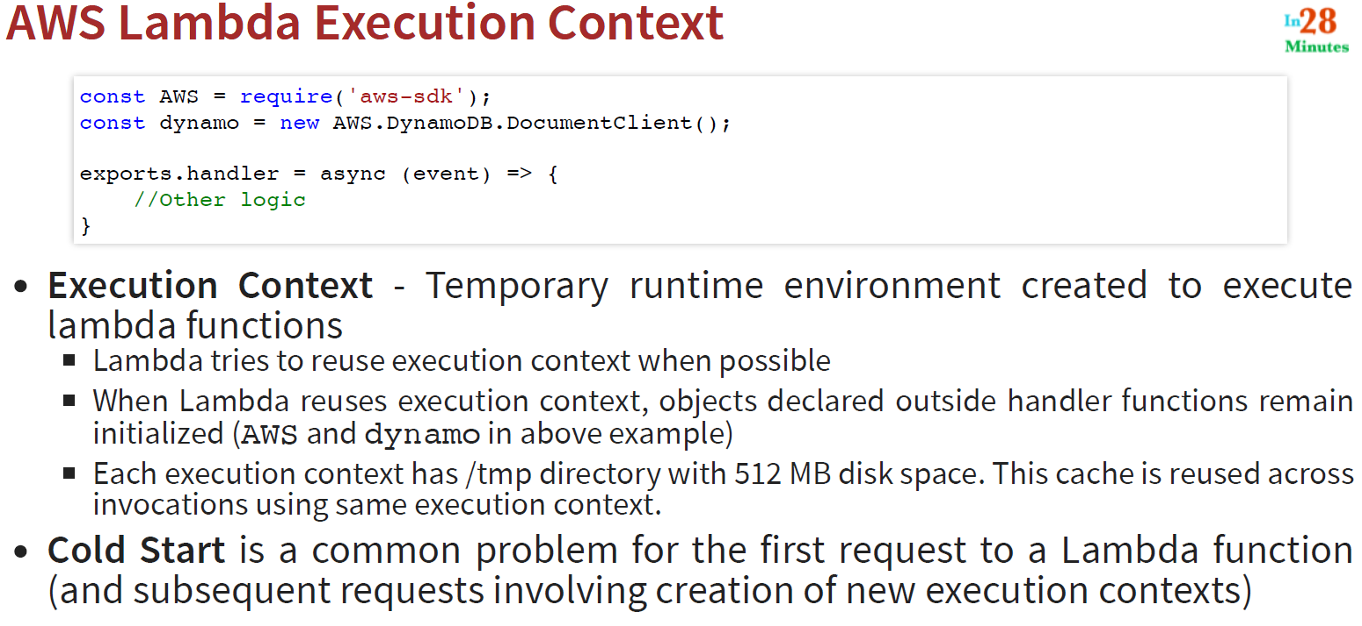

So here we have initialized Execution Context AWS and dynamo outside of the handler function and the advantage of this is that don’t need to initialize for every coming subsequent request.

Now when the first request will be received by the Lambda function then in the first request first it will initialized the Execution context to be used inside the handler function and from the next request onwards the processing will be faster because Execution context can be reuse further for subsequent request provided execution context is commonly used for all the request , this is called cold start.

**72. Step 03 - Understanding Provisioned Concurrency of Lambda Functions**

As in the previous we have discussed about the execution context which needs to be initialized and initialization of lambda function takes time and in result we get performance issue. To resolve this performance issue Provisioned Concurrency of Lambda function came into picture. In short:

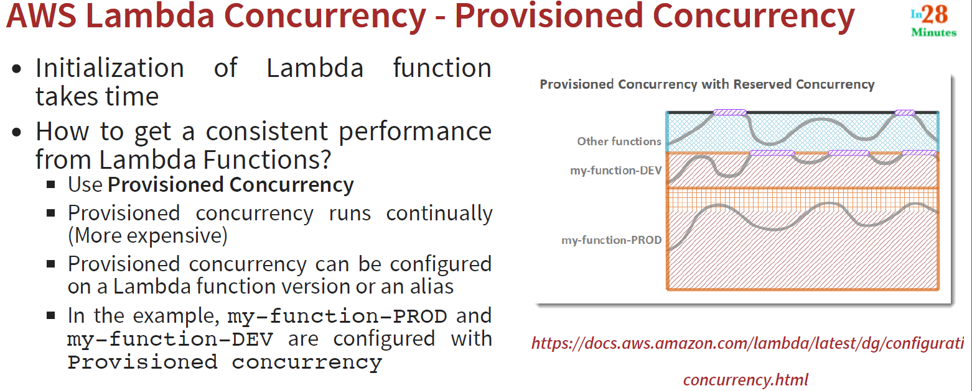

So once we configured a certain amount of Lambda function instances as provisioned concurrency, those many instances of lambda function will always be running where request comes or not.

Now let’s configure provisioned concurrency:

* Go to helloWorld lambda function > Under Concurrency section below this we will get provisioned concurrency.

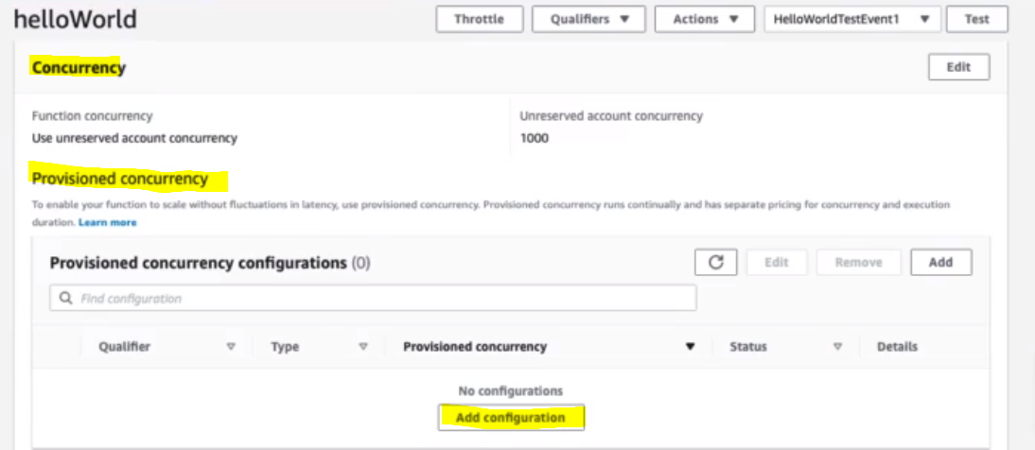 **Click Add Configuration:** 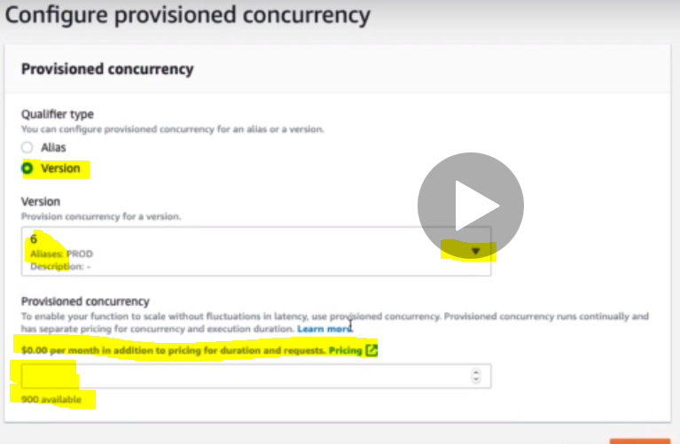

Now here we can select the Lambda function to be provisioned either by Alias or version. And we can mention how concurrency we want for this lambda function. So to avoid cold start of EC association with Lambda function.

But the drawback of this is that it is more expansive.

**73. Step 04 - Lambda Functions - What is Throttling?**

In the earlier steps we have seen the number of lambda functions concurrency to process the request, but what if the number of request becomes more than the function concurrency?

This case is called Throttling and in this case we will get Throttling error with 429 status code.

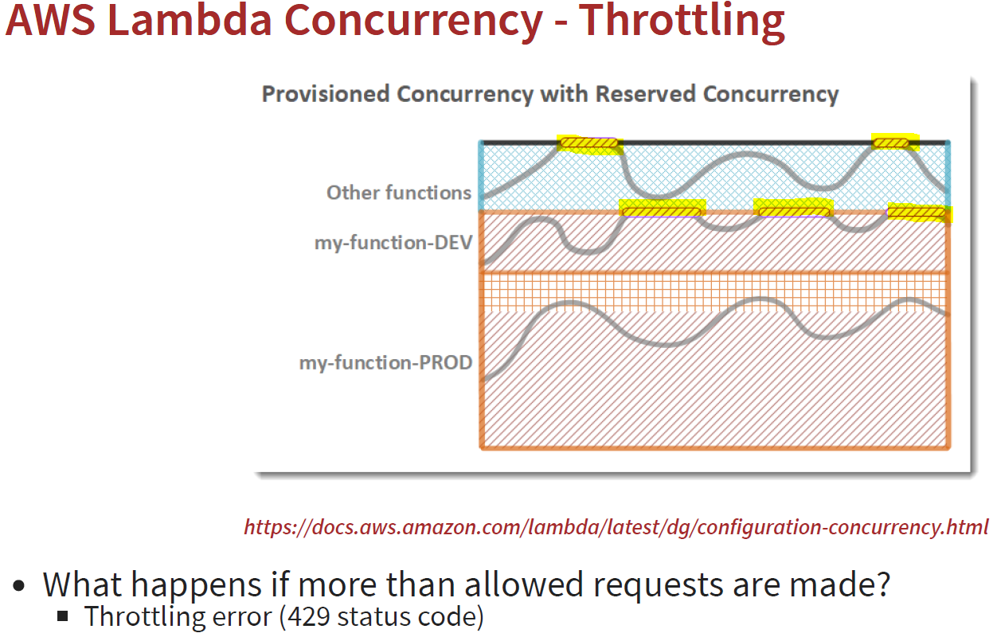

Here the yellow marked is showing the throttling error.

**74. Step 05 - Invoking Lambda Functions Synchronously**

When we talk about lambda function then there is two ways, we can invoke it.

1. Synchronous way of event
2. Asynchronous way of event

Note: Until now whatever the invocation we have done all are Synchronous way only where we have used AWS console to invoke the lambda function.

Another way we can invoke the lambda function using command line (AWS CLI) as given below.

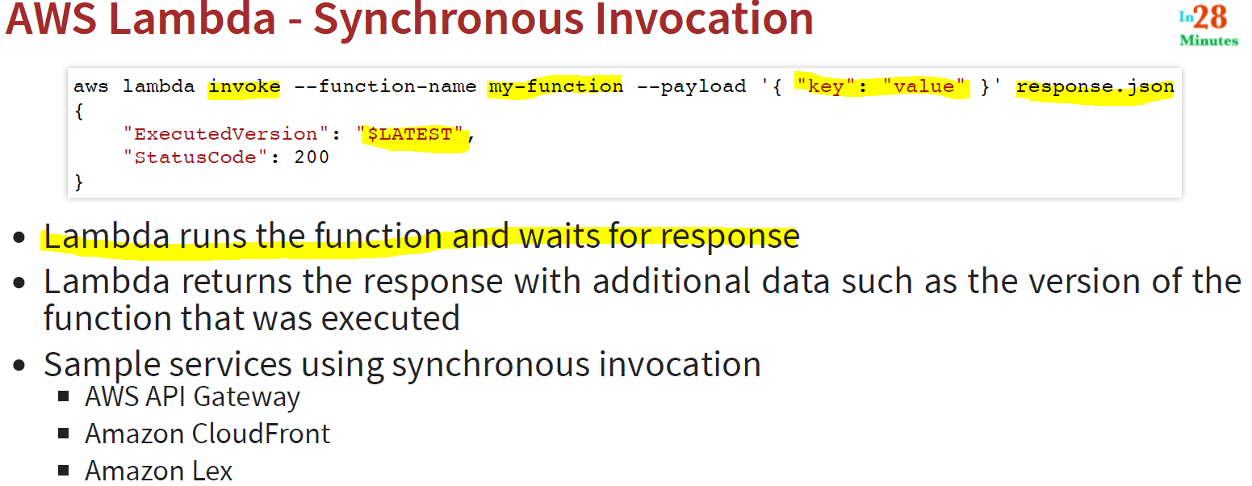

Here

* **invoke** is the keyword
* **my-function :** name of function
* **{ “key” :** “value”} : Payload to the function
* **Response.**json: output file where the response or output will be saved or stored
* **$LATEST:** is nothing the latest version of the lambda function which got executed along with status code

**75. Step 06 - Invoking Lambda Functions Asynchronously**

Invoking lambda function asynchronously is nothing but invoking event or information which just say like run and do not care about its response or where it is successfully executed or not.

So to invoke lambda functions asynchronously we will have to add [-- invocation-type Event] in the previous command line Invoking Lambda Functions Synchronously.

1. Typically asynchronous invocation is done for processing event from Amazon S3, Amazon SNS.
2. Once Lambda function receives the event, it places the event in the Event Queue and if event gets successfully executes then an invocation **success** record (JSON response) can be sent to other AWS services.
3. In case of failures, lambda function retries failed event two more times.
4. In case if an event is throttle, then lambda retires up to 6 hours with exponential backoff or time-periods ( like 2, 4, 16, 256 etc).
5. And after these tries line number 3,4 , again event invocations gets failed then the failed event can be sent to Dead Letter queue (SQS Queue or SNS topic)

In short:

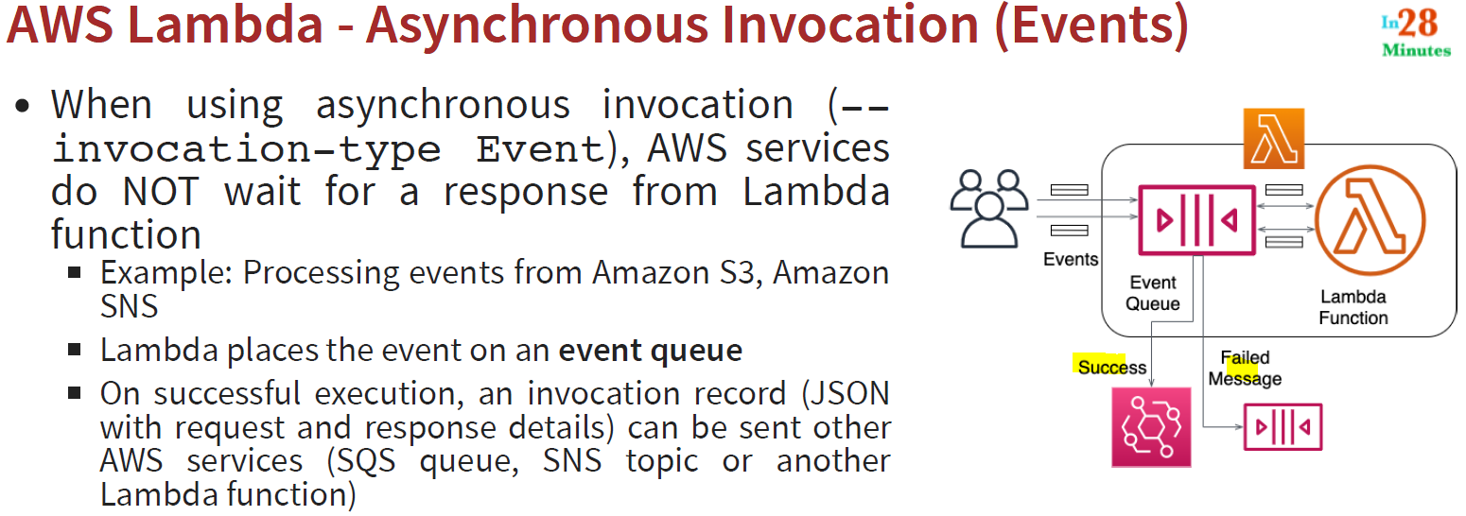 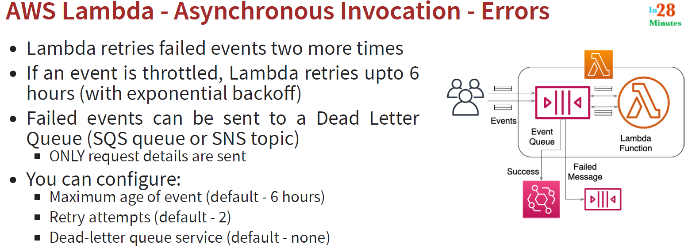

Now let’s configure the asynchronous invocations and retries.

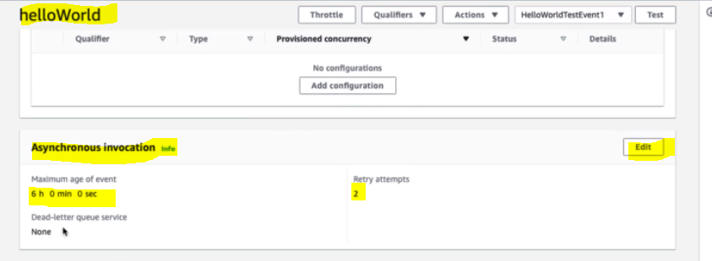

By default Retry attempts is 2 and max age is 6 hrs. We can edit this.

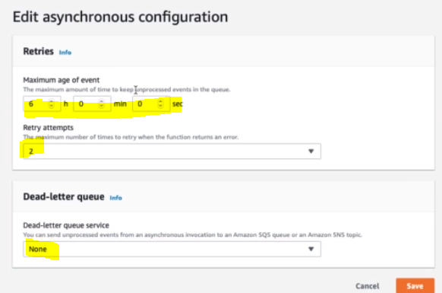

**76. Step 07 - 01 - Exploring AWS Lambda - Context Object**

In this step we will talk about the lambda request context object which is passed as parameter.

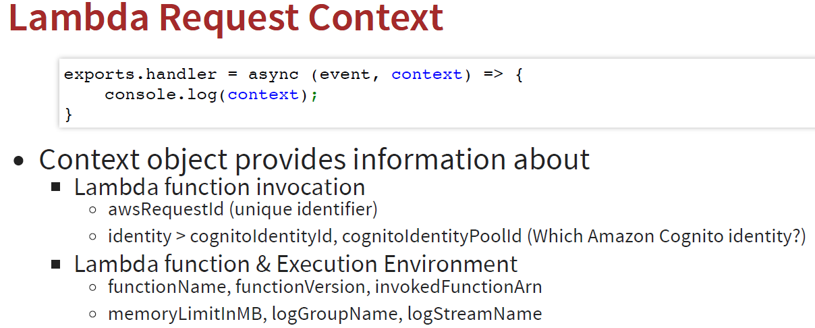

**77. Step 07 - 02 - Invoking Lambda Functions from CloudFront - Lambda@Edge**

1. Cloud Front is content delivery network (CDN), here Edge is nothing but the location. Cloud front is just like a cache, it is not owner of the content. It works as cached container between source and destination.

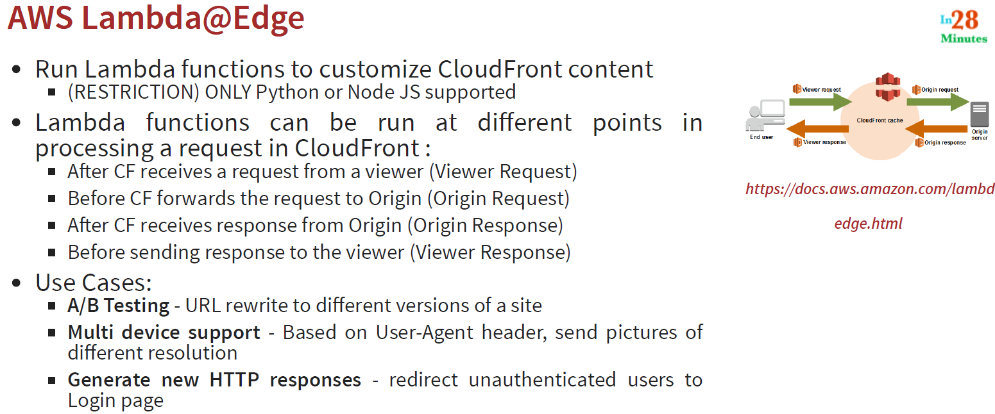

**78. Step 08 - Understanding Versioning of Lambda Functions**

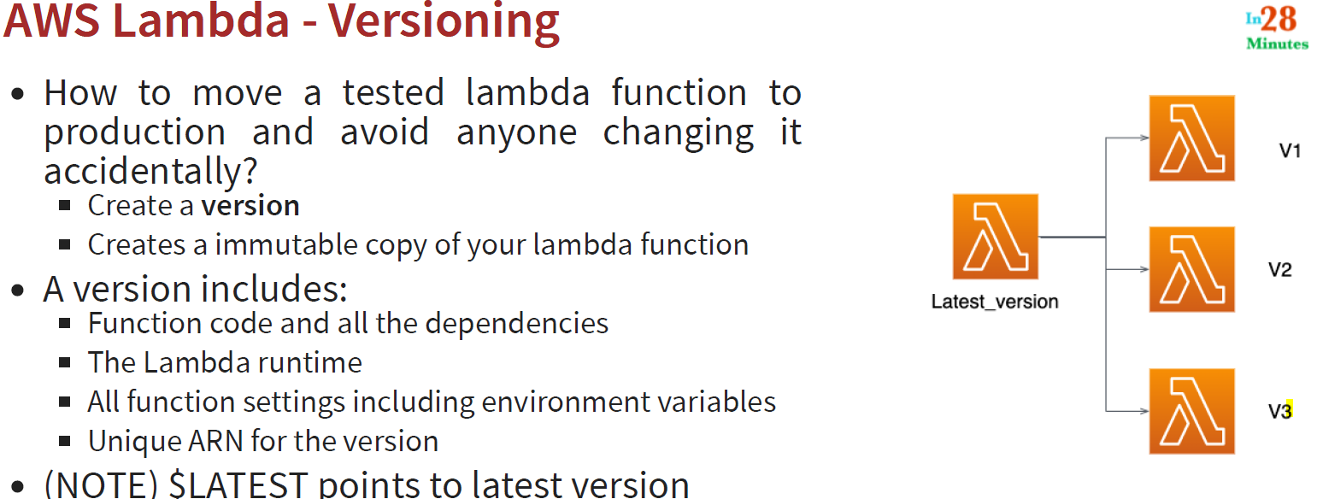

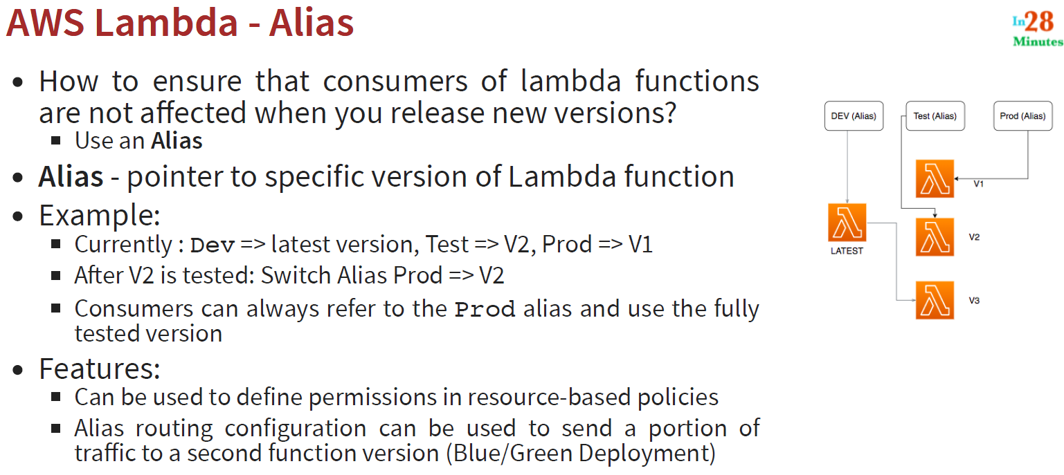

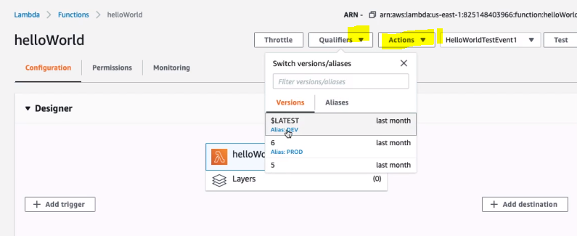

**80. Step 10 - Creating Layers for Lambda Functions**

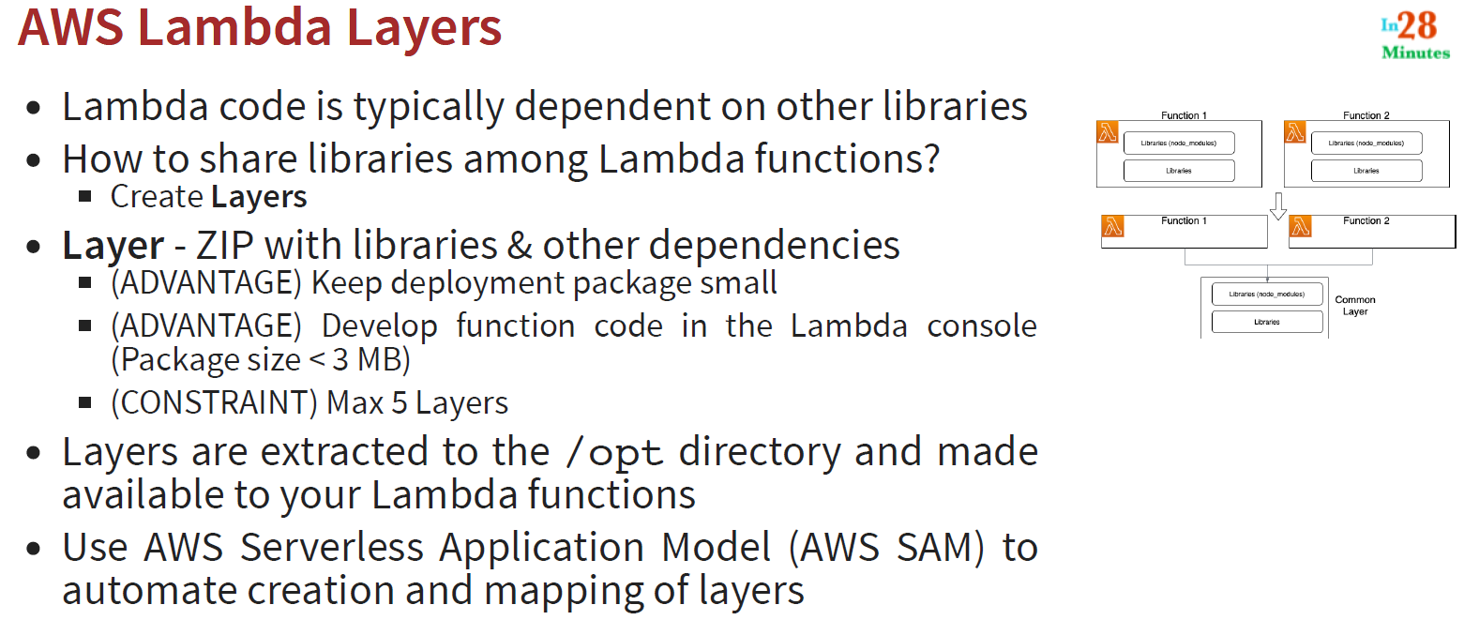

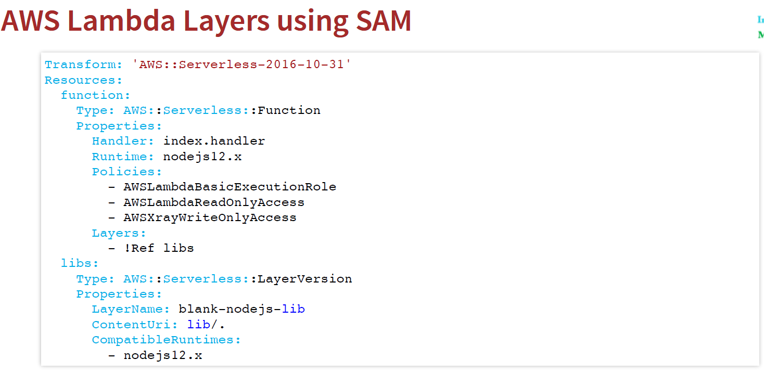

**81. Step 11 - Understanding AWS Lambda Best Practices**

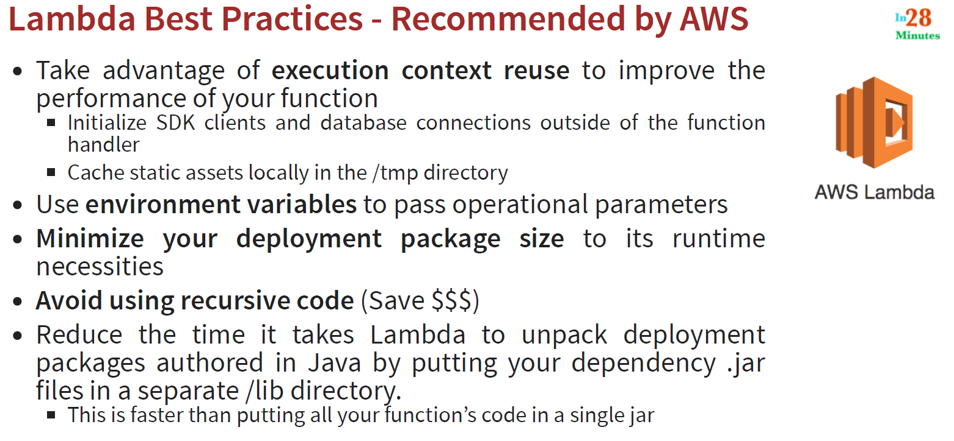

**82. Step 12 - Exploring AWS Lambda - Scenario Questions**

